This document is merely to point out the differences in confessional count numbers between my findings and the official numbers posted on Survivor Sucks. The guidelines I use can be found [here](https://docs.google.com/document/d/18ofsPiVWxSejzSjEGlU8KEx4Og2ddEJScCV23RsCPIA/edit?usp=sharing).

**Survivor Sucks Season 10 Counts** ([link](https://goo.gl/photos/fBmToHk34LfvBhph7))

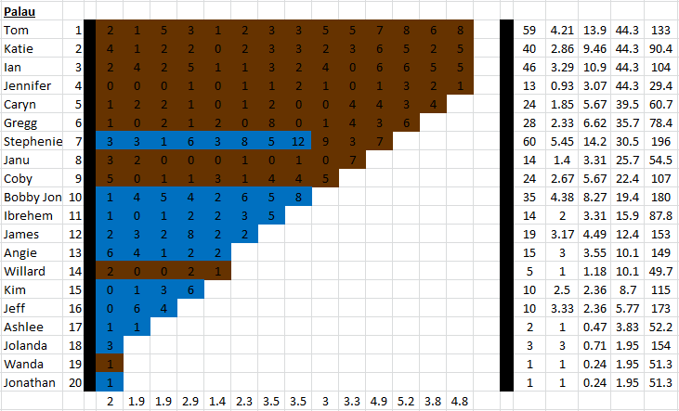

**My Season 10 Counts** ([link](https://goo.gl/photos/Ycanzdg1FwiA6FAk9))

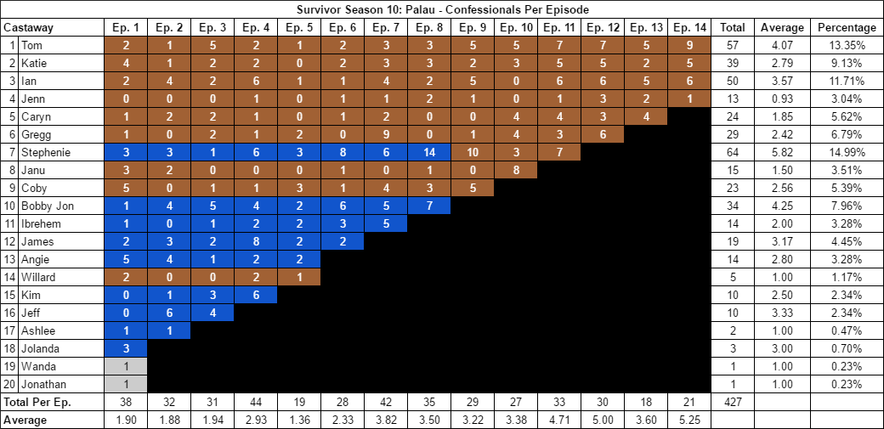

[Survivor Sucks Season 10 Confessional thread](http://survivorsucks.com/topic/2807#.Vu7eb0fpxtE).

**Differences**

[Episode 01](https://docs.google.com/document/d/1cTyvYQB3IeB8zIlW9uqZe0FGkCovy_r__PJ3cU9vwYY/edit?usp=sharing)

* **Angie: 5 (-1)** I got a count of 5 for Angie instead of the established 6. She doesn’t have any 9s gaps that may be questionable. Confessional #32 has an 11s gap.

[Episode 04](https://docs.google.com/document/d/1QbqomzFV0KJ44xGVaP2eJ2VE6yf-dErTudPUPizSyzY/edit?usp=sharing)

* **Tom: 2 (-1)** I only counted 2 confessionals for Tom. No significant time gaps.
* **Ian: 6 (+1)** I counted 6 confessionals for Ian.
  + Confessional #29 is an on-the-fly confessional of Ian on the campfire where his chyron appears on screen. I included it.

[Episode 07](https://docs.google.com/document/d/12BlB3dDxJiYV8VaYidwTaVctT34dq0X22Uxl3XUN-DM/edit?usp=sharing)

* **Ian: 4 (+1)** I counted 4 confessionals for Ian instead of the established 4.
* **Gregg: 9 (+1)** Confessional #8 is a voice over.
* **Stephenie: 6 (+1)** I counted 6 confessionals for Stephenie instead of the established 5. She has a couple of consecutive confessionals but they all have gaps over 10 seconds long.

[Episode 08](https://docs.google.com/document/d/11w6yBUjsu8V_XSpAhgfpyhn0Hy9_8uqNquAzY65hsGw/edit?usp=sharing)

* **Stephenie: 14 (+2)** Confessionals #14 & #20 both have 11s gaps, plus #20 is a voice over.
* **Coby: 3 (-1)** Confessional #28 has a 9s gap.
* **Bobby Jon: 7 (-1)** I counted 7 confessionals instead of the established 8. No significant time gaps.

[Episode 09](https://docs.google.com/document/d/1EvHZas7WotwbWYEWBSj5cFsDtuNX5ypee408xXfE_PY/edit?usp=sharing)

* **Ian: 5 (+1)** Confessional #13 is an on-the-fly confessional in which Ian narrates directly to the camera during the Reward and tribemates are seen on the background. No chyron present.
  + Note: Tom has a similar confessional (#14) under the same circumstances (including tribemates on the background and no chyron) which when included, gives him the established count of 5. Also, Coby has a similar confessional (#6) in which tribemates are tanning on the background, but his chyron is visible on screen. I included all as confessionals.
* **Stephenie: 10 (+1)** Stephenie has many voice overs during this episode including confessionals #1-4 & #23. She also has one on-the-fly confessional (#7) in which while fishing, she narrates to the camera and there is no visible chyron. I included all of them.

[Episode 10](https://docs.google.com/document/d/1RK1b3fgDSvM8LOBYxQHdHXK_-0y4bsFxaAKvUOjqpR8/edit?usp=sharing)

* **Janu: 8 (+1)** Confessionals #17 through #20 are all voice overs when Janu is on Exile Island. The only significant gap is a 12s gap between #17-18.

[Episode 11](https://docs.google.com/document/d/19JL4CQUzUnQfeyxDKreUljbMcGR3pRxt39C9GkaI7sY/edit?usp=sharing)

* **Katie: 5 (-1)** I counted 5 confessionals for Katie instead of the established 6. No significant time gaps.
  + Note: Confessional #16 is an on-the-fly confessional at camp with tribemates in the background and her chyron present.
* **Note:** Confessional #15 is a Jenn on-the-fly confessional at camp where Caryn walks behind her and her chyron is present.

[Episode 12](https://docs.google.com/document/d/12YZ8wlBvGlVchBXaiyvzIM-dDLHDDw34oFCUJohEY7Y/edit?usp=sharing)

* **Tom: 7 (-1)** I counted 7 confessionals for Tom instead of the established 8. No significant time gaps.

[Episode 13](https://docs.google.com/document/d/1SpEISYy-MBtIR8Vgik2NS2PcAU7MDj_AOKtqyaxASGA/edit?usp=sharing)

* **Tom: 5 (-1)** I counted 5 confessionals for Tom instead of the established 6. No significant time gaps.

[Episode 14](https://docs.google.com/document/d/1g-oJlYeUCK8WIsvoWc_W0wMdEx_1Qf09kXvtXKRpl0M/edit?usp=sharing)

* **Ian: 6 (+1)** I counted 6 confessionals for Ian instead of the established 5. He has 3 pairs of consecutive confessionals but none have significant gaps.
* **Tom: 9 (+1)** Confessionals #9 and #21 are voice overs. Also, confessional #17 has a 12s gap.

**No Change**

* [Episode 02](https://docs.google.com/document/d/1nWnN_ChA1cnrDrpjlDgtrmWqUBfK-0dsOp4rplnrhC4/edit?usp=sharing)
* [Episode 03](https://docs.google.com/document/d/1yR0LWnFwOR9m_lfhO12HeT_JrpgwHqCJwBYsy00t8JQ/edit?usp=sharing)
* [Episode 05](https://docs.google.com/document/d/1foz5MFDUpVHrc_y0jS4BkUrbrDSYuuhlNgvDKDWWlyE/edit?usp=sharing)
  + Confessional #7 is an Angie on-the-fly confessional at camp. No chyron on screen but she is narrating.
* [Episode 06](https://docs.google.com/document/d/1c8CrVQDNIqVz3C29IjZqhr3LcN0OebCYgcKTuLMhW-g/edit?usp=sharing)
  + Confessional #15 is a Stephenie on-the-fly confessional at the lake without a chyron.
  + Confessional #16 is a Tom on-the-fly confessional at the shelter during the storm with the chyron present.

|  |  |  |
| --- | --- | --- |
| **Castaway** | **Count** | **Change** |
| Angie | 14 | -1 |
| Bobby Jon | 34 | -1 |
| Coby | 23 | -1 |
| Janu | 15 | +1 |
| Stephenie | 64 | +4 |
| Gregg | 29 | +1 |
| Ian | 50 | +4 |
| Katie | 39 | -1 |
| Tom | 57 | -2 |
| **Total** | **427** | **+4** |

**Revised Sucks Counts** (link)

*Coming soon...*